Multi-Functional Fluid Flow Device

Summary
Cells within a body are exposed to interstitial fluid movements that stimulate morphologic and biochemical cell changes in response to their environment. The fluid flow device is an inexpensive, multifunctional adapter that fit the wells of traditional tissue culture plates to introduce fluid flow shear stress and pressure onto a monolayer of cells.

Market

Key Investigator
James Lyon
Joseph Stains
Christopher Ward

Field
Microfluidics

Technology
Research Tool

Advantages
Inexpensive
Multifunctional

Status
Available for licensing
Available for sponsored research

Patent Status
Provisional Patent application, pending

UMB Docket Reference
JL-2016-052

Fluid flow systems exist in the market that induce fluid flow stress and pressure to a cell monolayer. However, these stand alone systems can be costly and require the purchase of specialized plates, slides, and pumps. The ability to have a simple, versatile, and cost-effective system is highly sought after to conduct research in relevant physiological microenvironments. The microfluidics market is projected to reach $8.78 billion in 2021 and divided by applications into pharmaceutical research, in vitro diagnostics, and drug delivery. Pharmaceutical research is further divded into lab analytics (cell-based assays, proteomic analysis, genomic analysis, and capillary electrophoresis), dispensing, and microreaction.

Technology
Flow induced shear stresses and pressures are two parameters that are absent in traditional tissue culture systems. The fluid flow device is designed to sit over a tissue culture well with an inlet and outlet ports to control the shear force and pressure of fluid flow within a well. This device is easily adoptable to any sized tissue culture plate and amenable to real-time, live cell imaging where fluid flow dynamics mechanotransduction can be studied under physiologically relevant conditions.

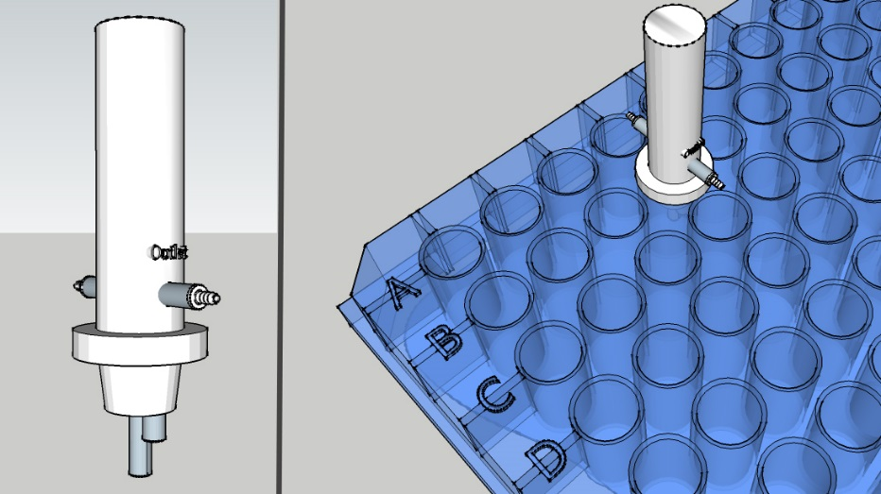

Technology Status
- Early prototype designs

