Inhibition of microtubule protrusions in suspended tumor cells to prevent metastasis

Summary
This technology consists of therapeutic compounds and a method of treatment to target microtubule protrusions, dubbed microtentacles, to inhibit or reduce metastases. Detached epithelial cells from cancerous tumors generate microtubule protrusions called microtentacles, that increase their ability to reattach to each other and other surfaces facilitating metastasis. These microtentacles facilitate invasion through the blood vessel and into secondary tissue sites.

Market

Key Investigator
Stuart Martin
Rebecca Whipple
Agnes Cheung

Field
Cancer Diagnostic/Therapeutic

Technology
Oncology

Technology Status
Lead compounds identified
In vitro and in vivo POC studies completed

Status
Available for licensing
Available for sponsored research

Patent Status
US Paten 8,193,238 issued 6/5/2012

UMB Docket Reference
SM-2006-059

External Reference
Video – Cancer Metastasis Prevention
Oncogene. 2010 Jun 3;29(22): 321727.
Cancer Res. 2008 Jul 15;68(14): 5678-88.
Exp Cell Res. 2007 Apr 15;313(7): 1326-36.
In 2017, there will be an estimated 1,688,780 new cancer cases diagnosed and 600,920 cancer deaths in the US (ACS). Cancer is the second-leading cause of death in the United States and most often caused by metastatic spread of tumor cells from the primary tumor site through the bloodstream. Metastasized tumor cells can lie dormant for an extended periods of time before progressing into secondary sites such as the lung, liver or kidney.

Technology
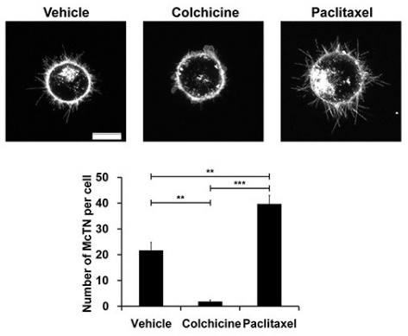
Inventors at the University of Maryland, Baltimore have elucidated the composition and mechanisms of action of microtubule protrusion, called microtentacles that facilitate the reattachment and invasion of metastasized cells through the blood vessel and into secondary tissue. The frequency and length of microtentcles have been shown to increase aggregation, correlates with the metastatic potential of tumor cells, and patient mortality. Known and novel compounds that block their formation are currently under investigations. This invention is directed to a system, methods, and compositions that relates to cancer therapy. Specifically, this invention is directed to preventing metastasis in cells by targeting microtentacle structures.

Advantages
- Cancer therapies (e.g., for breast, prostate, colon, lung, liver, brain, ovarian, cervical cancers).
- Consists of a method for treating, novel targets and lead candidate compounds for reducing cancer metastasis.
- Novel therapeutics would be given pre and post solid tumor chemotherapy, surgery or radiation therapy to prevent the formation of metastatic tumors.

